Performance and Spending Data Workbook README
EXECULTIVE SUMMARY
In order to consolidate .csv-based data sheets for a $5 million workforce program, I built a tool to easily track performance and spending across four different regional workforce agencies. The tool provided quarterly updates on key performance and spending data that were easily transferred to reports and presentations, and which led to strategic funding re-allocations that increased outcomes by 12 percent. The tool was recognized by the U.S. Department of Labor as a “best practice” and encouraged other program managers to adopt it.

BACKGROUND
In February 2022, I joined the Michigan Department of Labor (MiDOL) to serve as data analyst and project manager for a healthcare workforce initiative. MiDOL disbursed funds from a federal healthcare workforce grant to four workforce agencies that partnered with educational institutions to train Michigan residents for a select number of high-demand healthcare jobs. I was charged with holding strategy meetings with the workforce agencies, analyzing program progress, and creating reports for local, state, and national stakeholders.
When I began my work, all MiDOL program data was recorded and visualized through Microsoft Excel. As such, I created my own Excel document that consolidated all monthly reports from workforce agencies into a single workbook. Doing so made data entry simpler and allowed for easy tracking of progress over time and between agencies.

METHODS
The workbook contains fields for manual performance data entry for each workforce agency, which were input manually based on the reports they emailed to us.
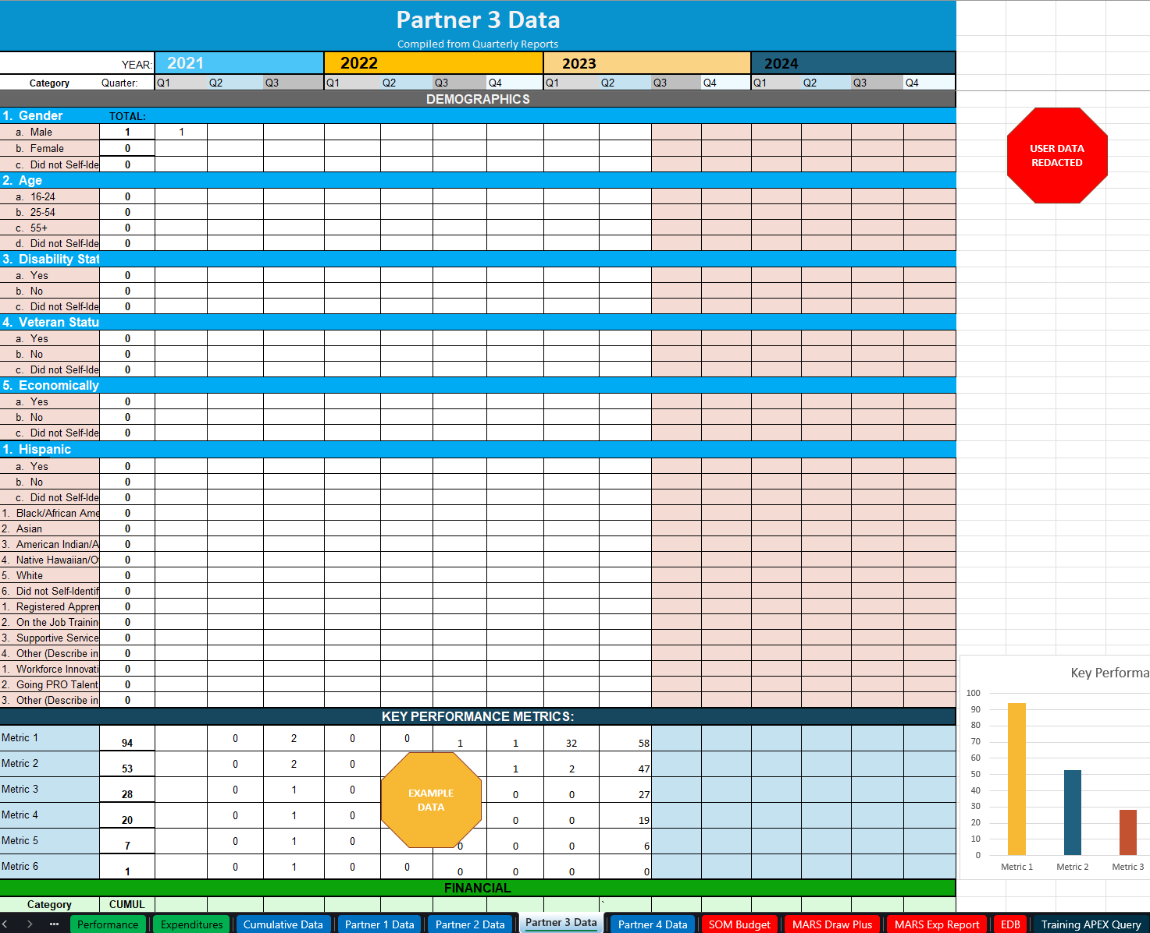

In addition, I entered financial data pulled from the MiDOL database so that performance and spending could be analyzed in relation to one another.
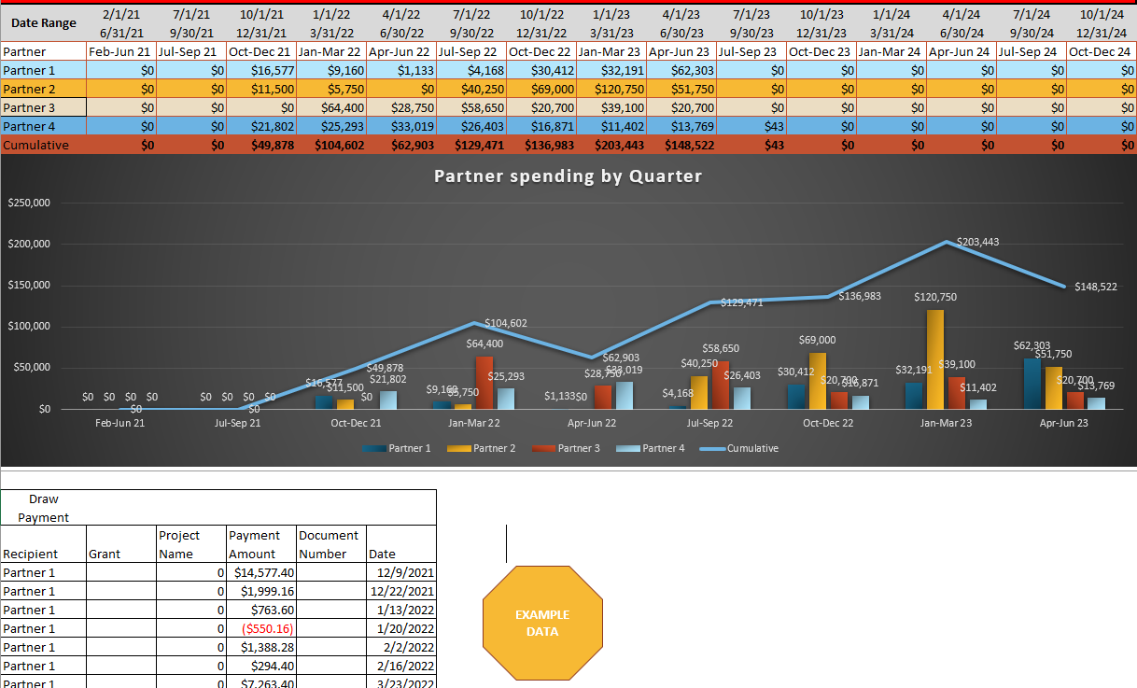
Taken together, using simple formulas like sums, I was able to easily visualize performance and spending data for individual agencies and the program in aggregate, based on the most recent quarterly data. These visualizations were easily pasted into PowerPoint presentations to demonstrate performance.
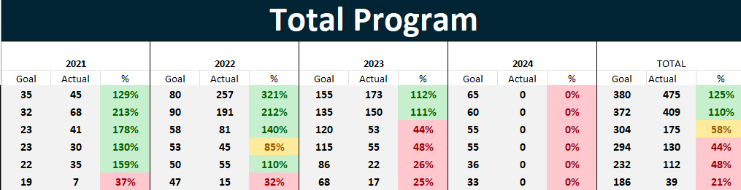
Key Performance Indicators included:
- Number of participants (jobseekers) enrolled in the program.
- Number of participants who began training.
- Number of participants who completed training.
- Number of participants who earned an educational/training credential.
- Number of participants who earned a credential and found full-time, relevant work.

Key Financial Indicators included:
- Highest and lowest agency expenditures
- Total expenditures by quarter

OUTCOMES
At the 2024 annual meeting of Michigan workforce agencies, I gave a presentation on this tool, demonstrated how it worked, and offered a template to those interested.
When our program was audited by the U.S. Department of Labor, it praised the tool as a “best practice” and encouraged nationwide this data tracking tool was praised as “best practice” and encouraged other recipients of the healthcare workforce grant to adopt it.

